**Insights and Analysis**

**1] Age Distribution by Subscription Status**

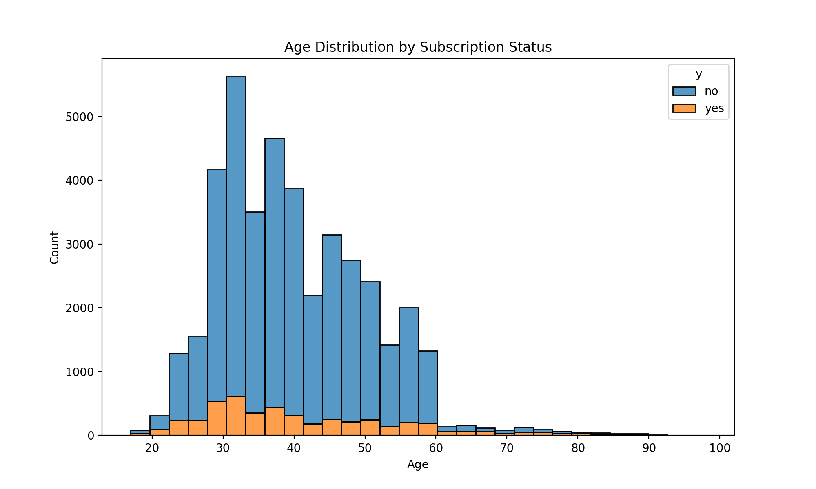

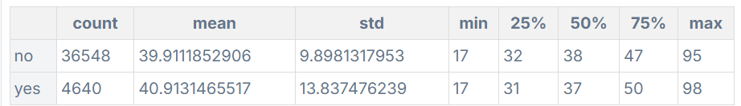

**The age distribution shows that subscribers ('yes') tend to be slightly older than non-subscribers.**

**2] Subscription rate by Job**

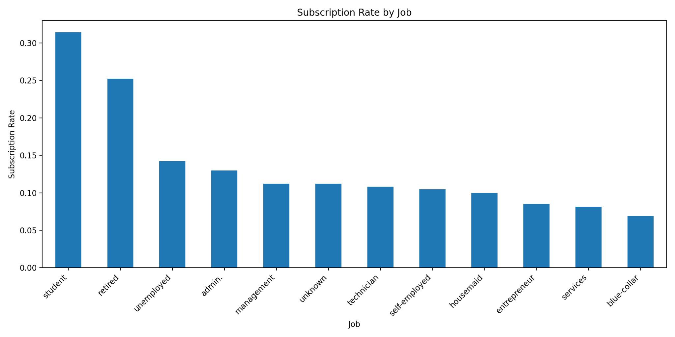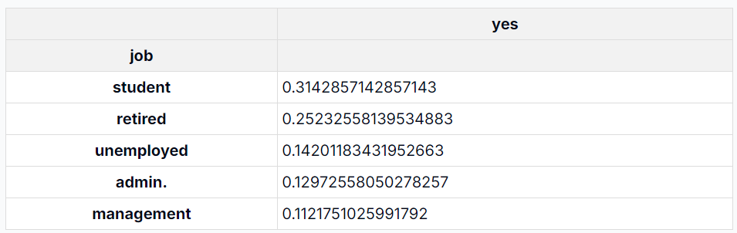

**Students and retired individuals have the highest subscription rates, while**

**Management and admin jobs are also in the top 5.**

**3] Confusion Matrix**

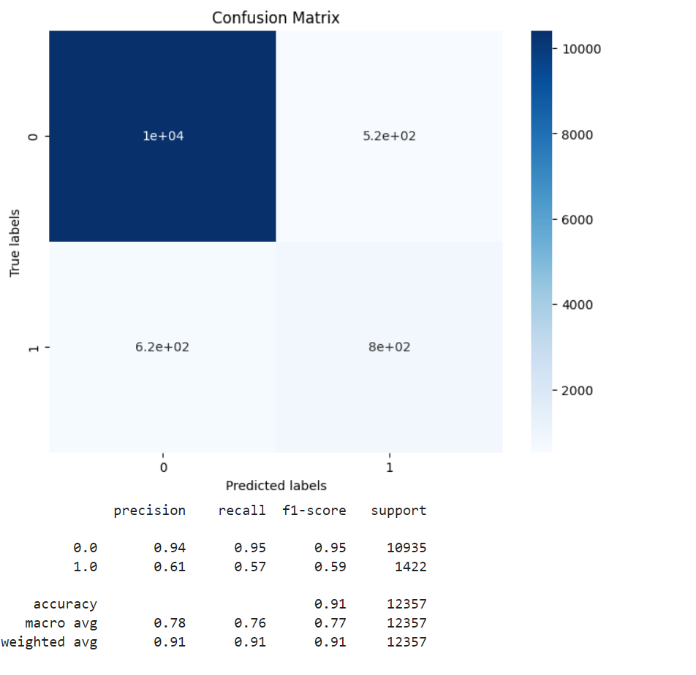

**1. Model Overview:**

**This appears to be a binary classification model, with two classes (0 and 1). The model has been evaluated on a dataset of 12,357 samples.**

**2. Confusion Matrix:**

**- True Negatives (TN): 10,000**

**- False Positives (FP): 520**

**- False Negatives (FN): 620**

**- True Positives (TP): 800**

**3. Class Distribution:**

**- Class 0: 10,935 samples (88.5% of the dataset)**

**- Class 1: 1,422 samples (11.5% of the dataset)**

**This indicates a significant class imbalance in the dataset.**

**4. Model Performance:**

**a) Overall Accuracy: 0.91 (91%)**

**The model correctly classifies 91% of all samples, which is generally good.**

**b) Class 0 (Majority Class):**

**- Precision: 0.94**

**- Recall: 0.95**

**- F1-score: 0.95**

**The model performs very well on the majority class.**

**c) Class 1 (Minority Class):**

**- Precision: 0.61**

**- Recall: 0.57**

**- F1-score: 0.59**

**The model struggles more with the minority class.**

**5. Key Insights:**

**a) Class Imbalance Impact: The significant class imbalance (88.5% vs 11.5%) likely contributes to the model's performance disparity between classes. It performs much better on the majority class (0) than the minority class (1).**

**b) High Overall Accuracy but Misleading: While the 91% accuracy seems high, it's important to note that this is influenced by the class imbalance. The model could achieve 88.5% accuracy by simply predicting the majority class for all samples.**

**c) Minority Class Challenge: The model has difficulty with the minority class (1), as evidenced by the lower precision, recall, and F1-score. This suggests that the model might benefit from techniques to address class imbalance, such as oversampling, undersampling, or using class weights.**

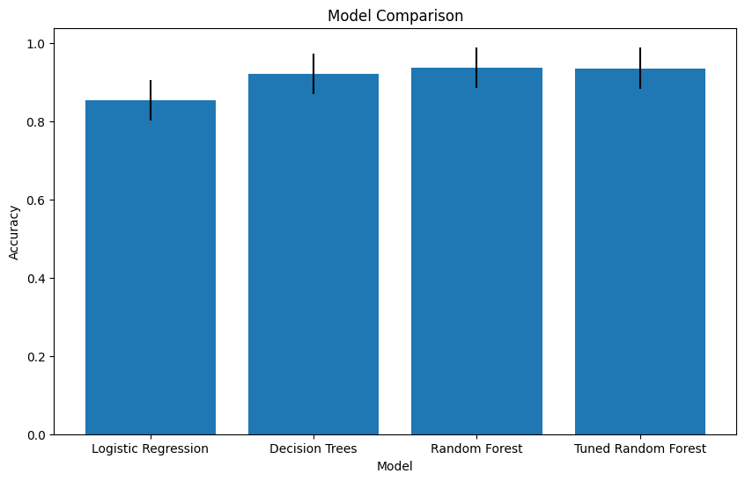

**d) False Negatives vs False Positives: There are more false negatives (620) than false positives (520). This means the model is slightly more likely to incorrectly classify a positive sample as negative than vice versa.**

**e) Macro vs Weighted Averages: The macro average (which gives equal weight to each class) shows lower performance (F1-score: 0.77) compared to the weighted average (F1-score: 0.91). This further highlights the impact of class imbalance on the model's performance metrics.**